**JAYPEE INSTITUTE OF INFORMATION TECHNOLOGY NOIDA**

**DEPARTMENT OF SOFTWARE DEVELOPMENT** **FUNDAMENTALS**



Project Based Learning

REPORT

On

**“TRAVEL MANAGEMENT SYSTEM”**

Submitted By – Under the Supervision of –

❖ ADITYA JAMWAL (20103283) B10 MRS. BHAWNA SAXENA

❖ HARSH DHANWANI (20103274) B10

❖ ADITI JAIN (20103273) B10

❖ GOVIND GOEL (20103279) B10

# INTRODUCTION

This is a simple project where the system maintains the inventory data of the customers who wants to travel from one place to another. If a customer is getting registered, he would receive a unique code, his personal details would be asked; and details of the acceptance code would be shown for the same. Notice the data file handling. We can modify the code to add another field of destination of place or make more entries into the data file as well. We can make the use of search based on selected fields. The details are cumulative stored in a text file. Search using just one parameter giving multiple results based on necessity. Travel Management System is the web application to automate all kinds of operations such as viewing travelling/ personal details, computing bill, editing and formatting the text file based on the same. The purpose of this software is to manage the travelling details of people.

**ANALYSIS**

**a) Scope of project:**

* The aim of project is to provide the traveling services to the customers at reasonable rate. Through this project provide the facilities to the customer such as registration, display, search, modify, delete etc.
* **Registration of new customer:**

In Registration option add the client information such as client name, address, client no, phone no, total cost of travels, date of registration

* **Display:**

In Display option, read the all client information such as client no, client name, address, phone no and cost.

* **Search:**

In search option, search the information about particular client ,such as client no client name, phone no, date of registration and cost.

* **Modify:**

In modify option, update the particular client no, name, address, phone no and cost.

* **Delete:**

In delete option, delete the record of particular client no, name, address, phone no cost and date of registration.

**the requirements**

**Hardware requirements:**

Minimum requirements of 64 MB RAM.

**Software requirements:**

VS Code

C++

Windows XP

**FLOWCHARTS**

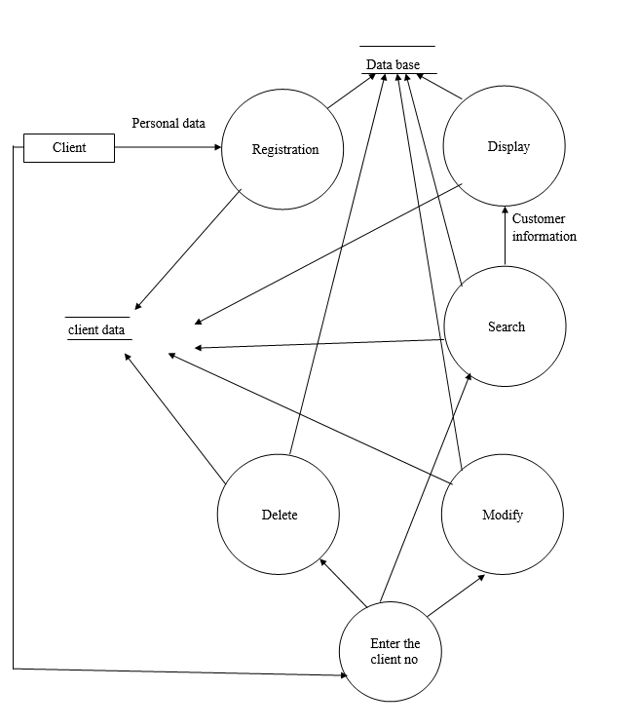

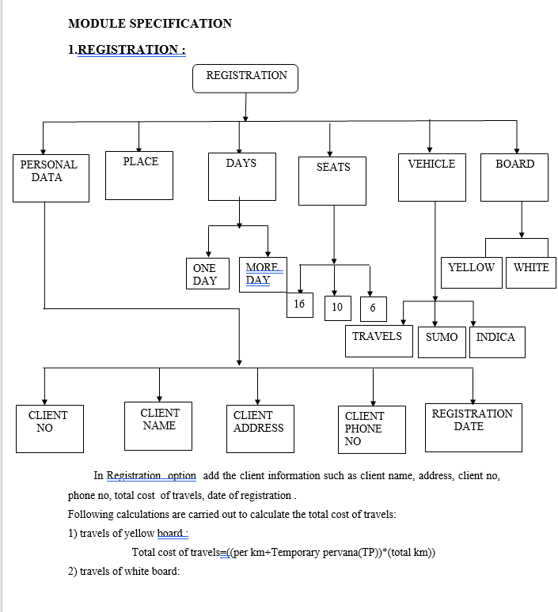

# 

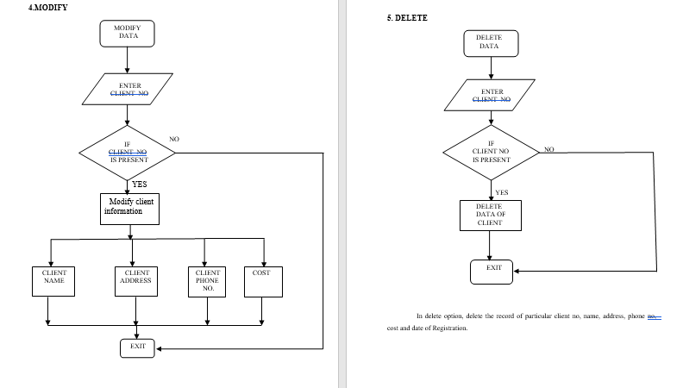

# SOURCE CODE

/*    Travel Agency Program

Authors               Enrollment No.

Aditya Jamwal          20103283

Harsh Dhanwani         20103274

Govind Gopal Goel      20103279

Aditi Jain             20103273

*/

#include<iostream>

#include<conio.h>

#include<stdio.h>

#include<process.h>

#include<fstream>

#include<cctype>

#include<stdio.h>

#include<stdlib.h>

#include<iomanip>

using namespace std;

long int code;

class PersonalDetails //class for collecting the personal details

{

    int TravelCode,age[20],num,numppl;

    char Name[20][20], Address[50], PhoneNumber[15], gender[20], PassportNum[9][9],FamilyName[30];

    public:

        void p_input(int cd)

        {

            TravelCode = cd;

            num = 0;

            cout<<"\n\n:::::::::::::::::::::: PERSONAL DETAILS ::::::::::::::::::::::\n";

            cout<<"\n* Please fill in the details:\n1.Family Name: ";

            cin.ignore();

            cin.getline(FamilyName,30);

            cout<<"\n2.Address: ";

            cin.ignore();

            cin.getline(Address,50);

            cout<<"\n3.Contact Number(10 Digit Mobile Number) : ";

            cin.ignore();

            cin.getline(PhoneNumber,15);

            cout<<"\nEnter The No of People Travelling: ";

            cin>>numppl;

            system("cls");

            if(numppl>0)

            {

                cout<<"\nPlease Enter The Details of each Member/Members: "<<endl;

                for(int i=0;i<numppl;i++)

                {

                    cout<<endl<<"\nMember "<<i+1;

                    cout<<"\n~~~~~~~~~~~~~~~";

                    cout<<"\nFirst Name: ";

                    cin.ignore();

                    cin.getline(Name[i],20);

                    cout<<"\nAge: ";

                    cin>>age[i];

                    cout<<"\nSex (M/F): ";

                    cin>>gender[i];

                    cout<<"\nPassport Number: ";

                    cin.ignore();

                    cin.getline(PassportNum[i],9);

                    if(age[i]<5)

                    {

                        num++;    //to calculate no of travellers below 5 yrs

                    }

                }

            }

        }

        void p_output()

        {

            system("cls");

            cout<<"\n\n******* PERSONAL DETAILS *******"<<endl;

            cout<<"\nFamily Name: "<<FamilyName<<endl;

            cout<<"Address: "<<Address<<endl;

            cout<<"Phone Number: "<<PhoneNumber<<endl;

            cout<<"\nName\t\tAge\t\tSex\t\tPassport Number\n"<<endl;

            for(int i=0;i<numppl;i++)

            {

                cout<<"\t"<<Name[i]<<"\t\t"<<age[i]<<"\t\t"<<gender[i]<<"\t\t"<<PassportNum[i]<<endl;

            }

            getch();

        }

        void givefam();

        int givecode();

        int givenum();

}PD;

int PersonalDetails::givenum()

{

  return numppl-num;

}

void PersonalDetails::givefam()

{

  cout<<FamilyName;

}

int PersonalDetails::givecode()

{

  return TravelCode;

}

void boardpt(int c)  //for easy o/p

{

  if(c==1)

  cout<<"Mumbai\t";

  if(c==2)

  cout<<"Cochin\t";

  if(c==3)

  cout<<"Chennai\t";

}

void dest(int d)  //for easy o/p

{

  switch(d)

  {

    case 1:cout<<"New York";

       break;

    case 2:cout<<"Miami";

       break;

    case 3:cout<<"Rio De Janero";

       break;

    case 4:cout<<"Colombo";

       break;

    case 5:cout<<"Hong Kong";

       break;

    case 6:cout<<"Dubai";

       break;

    case 7:cout<<"Lisbon";

       break;

    case 8:cout<<"London";

       break;

    case 9:cout<<"Copenhagen";

       break;

   case 10:cout<<"Cape Town";

       break;

   case 11:cout<<"Antananriv";

       break;

   case 12:cout<<"Cairo";

       break;

   case 13:cout<<"Perth";

       break;

   case 14:cout<<"Sydney";

      break;

   case 15:cout<<"Willington";

     break;

  }

}

class TravelDetails

{

    int TravelCode, day,month,year,num1,BoardingPoint,DisembarkingPoint;

    int Class,pool,gym,sports,salon,spa;

    public:

        void initial()

        {

            pool=gym=sports=salon=0;

        }

        void t_input(int cd)

        {

            initial();

            TravelCode= cd;

            int i=1,opt;

            system("cls");

            do

            {

                system("cls");

                cout<<endl;

                cout<<"\nTRAVEL DETAILS\n";

                cout<<"~~~~~~~~~~~~~~~~~";

                cout<<"\nPlease enter the following details for your journey:";

                cout<<"\n*Note:Options marked with '*' are compulsory.\tPlease do select them.";

                cout<<"\n*1.Boarding and Destination\n*2.Date of Departure\n*3.Class\n4.Swimming Pool\n5.Gymnasuim\n6.Sports\n7.Salon\n8.Spa\n9.Back\n";

                cin>>opt;

                switch(opt)

                {

                    case 1:system("cls");

                        cout<<"\nSelect Boarding point:\n1.Mumbai\n2.Cochin\n3.Chennai";

                        cin>>BoardingPoint;

                        cout<<"\n*** Select Destination ***\n";

                        cout<<"1.New York\t\t6.Dubai\t\t\t11.Antananariv";

                        cout<<"\n2.Miami\t\t7.Lisbon\t\t12.Cairo";

                        cout<<"\n3.Rio De Janeiro\t8.London\t\t13.Perth";

                        cout<<"\n4.Colombo\t\t9.Copenhagen\t\t14.Sydney";

                        cout<<"\n5.Hong Kong\t\t10.Cape Town\t\t15.Wellington\n";

                        cin>>DisembarkingPoint;

                        break;

                    case 2:system("cls");

                        cout<<"\n\nEnter your preferred date(DD MM YYYY) of departure: ";

                        cin>>day>>month>>year;

                        break;

                    case 3:system("cls");

                        cout<<"\n\nEnter The Choice OF Class\n1.First Class\n2.Business Class\n3.Economy Class\n";

                        cin>>Class;

                        break;

                    case 4:system("cls");

                        cout<<"\n\nWould You Like To Avail The Facility Of A Swimming Pool\n0.No\n1.Yes\n";

                        cin>>pool;

                        break;

                    case 5:system("cls");

                        cout<<"\n\nWould You Like To Avail The Facility Of A Gymnasium\n0.No\n1.Yes\n";

                        cin>>gym;

                        break;

                    case 6:system("cls");

                        cout<<"\n\nWould You Like To Avail The Sports Facilities Offered\n0.No\n1.Yes\n";

                        cin>>sports;

                        break;

                    case 7:system("cls");

                        cout<<"\n\nWould You Like To Avail The Facility Of Beauty Salon\n0.No\n1.Yes\n";

                        cin>>salon;

                        break;

                    case 8:system("cls");

                        cout<<"\n\nWould You Like To Avail The Facility Of Spa\n0.No\n1.Yes\n";

                        cin>>spa;

                        break;

                    case 9:i=0;

                        break;

                }

            }while(i==1);

        }

        void t_output()

        {

            system("cls");

            cout<<"\n\n##############TRAVEL DETAILS##############";

            cout<<"\nBoarding Point: ";

            boardpt(BoardingPoint);

            cout<<"\nDestination: ";

            dest(DisembarkingPoint);

            cout<<"\nDate of departure: ";

            cout<<day<<"/"<<month<<"/"<<year;

            cout<<"\nClass: ";

            switch(Class)

            {

                case 1:cout<<"First Class";

                    break;

                case 2:cout<<"Business Class";

                    break;

                case 3:cout<<"Economy Clss";

                    break;

            }

            cout<<"\n\n\n\tFacilities availed for are:";

            if(pool==1)

            cout<<"\nSwimming Pool";

            if(gym==1)

            cout<<"\n";

            if(sports==1)

            cout<<"\n";

            if(spa==1)

            cout<<"\nSpa";

            if(salon==1)

            cout<<"\nBeauty Salon";

            getch();

        }

        void compute()

        {

            long int gttl=0,hr,dcst,cls,cabn,swpool=5000,gm=2000,spfts=7500,slon=6000,sp=20000,ttr=500;

            switch(DisembarkingPoint)

            {

                case 1:;

                case 2:;

                case 3:hr=30*24;

                    dcst=250000;

                    break;

                case 4:;

                case 5:;

                case 6:hr=7*24;

                    dcst=75000;

                    break;

                case 7:;

                case 8:;

                case 9:hr=24*24;

                    dcst=130000;

                    break;

                case 10:;

                case 11:;

                case 12:hr=15*24;

                    dcst=100000;

                    break;

                case 13:;

                case 14:;

                case 15:hr=12*24;

                    dcst=120000;

                    break;

            }

            switch(Class)

            {

                case 1:cls=1500;

                break;

                case 2:cls=7500;

                break;

                case 3:cls=5000;

            }

            system("cls");

            cout<<"\n\n:::::::::::::::::::::: BILL ::::::::::::::::::::::::::";

            cout<<"\nBoarding point: ";

            boardpt(BoardingPoint);

            cout<<"\nDestination: ";

            dest(DisembarkingPoint);

            cout<<"\nDate of Departure: ";

            cout<<day<<"/"<<month<<"/"<<year;

            hr=hr/24;         //to calculate date of arrival

            day=day+hr;

            if(month==1||month==3||month==5||month==7||month==8||month==10||month==12)

            {

                if(day>31)

                {

                month=month+1;

                day=day%31;

                }

            }

            if(month==4||month==6||month==9||month==11)

            {

                if(day>30)

                {

                month=month+1;

                day=day%30;

                }

            }

            if(month==2)

            {

                if(day>28)

                {

                month=month+1;

                day=day%28;

                }

            }

            if(month==13)

            {

                month=1;

                year++;

            }

            cout<<"\nDate of Arrival: ";

            cout<<day<<"/"<<month<<"/"<<year;

            cout<<"\n\nSubject\t\tCost(for 1)\tNo of ppl\tTotal";

            cout<<"\n\nTravel\t\t"<<dcst<<"\t\t   "<<num1<<"\t\t"<<num1*dcst;

            gttl+=num1*dcst;

            cout<<"\nClass\t\t"<<Class<<"\t\t   "<<num1<<"\t\t"<<Class*num1;

            gttl+=Class*num1;

            if(pool==1)

            {

                cout<<"\nSwimming Pool\t"<<swpool<<"\t\t   "<<num1<<"\t\t"<<swpool*num1;

                gttl+=swpool*num1;

            }

            if(gym==1)

            {

                cout<<"\nGym\t\t"<<gm<<"\t\t   "<<num1<<"\t\t"<<gm*num1;

                gttl+=gm*num1;

            }

            if(sports==1)

            {

                cout<<"\nSports\t\t"<<spfts<<"\t\t   "<<num1<<"\t\t"<<spfts*num1;

                gttl+=spfts*num1;

            }

            if(salon==1)

            {

                cout<<"\nSalon\t\t"<<slon<<"\t\t   "<<num1<<"\t\t"<<slon*num1;

                gttl+=slon*num1;

            }

            if(spa==1)

            {

                cout<<"\nSpa\t\t"<<sp<<"\t\t   "<<num1<<"\t\t"<<sp*num1;

                gttl+=dcst*num1;

            }

            cout<<"\nGrand Total:Rs ";

            if(gttl>100000)     //to provide comma's for grandtotal

            {

                cout<<gttl/100000<<",";

                gttl=gttl%100000;

            }

            if(gttl>1000)

            {

                cout<<gttl/1000<<",";

                gttl=gttl%1000;

            }

            cout<<gttl;

            if(gttl<10)

                cout<<"00";

            cout<<"\nAll Travellers below the age of 5 have not been charged";

            getch();

        }

        int gtcode();

        void accept(int);

}TD;

void TravelDetails::accept(int c)

{

  num1=c;

}

int TravelDetails::gtcode()

{

  return TravelCode;

}

void family(int c,int&flag)  //to display familyname+to check for record

{

  flag=0;

  system("cls");

  ifstream ifl("PersonalDetails.txt",ios::binary);

  if(!ifl)

    cout<<"\nError";

  ifl.read((char*)&PD,sizeof(PD));

  while(!ifl.eof())

  {

    if(PD.givecode()==c)

    {

      flag=1;

      break;

    }

    ifl.read((char*)&PD,sizeof(PD));

  }

  if(flag==1)

  {

    PD.givefam();

    cout<<"'s FAMILY DATABASE **";

  }

  else

  {

    cout<<"\nError in locating record!!";

  }

  ifl.close();

}

void editp(int c)  //to edit persdetails

{

  ofstream ofl2("temp1.txt",ios::binary);

  if(!ofl2)

  cout<<"Error While Opening File";

  ifstream ifl4("PersonalDetails.txt",ios::binary);

  if(!ifl4)

  cout<<"Error While Opening File";

  ifl4.read((char*)&PD,sizeof(PD));

  while(!ifl4.eof())

  {

    if(PD.givecode()==c)

    {

      system("cls");

      cout<<"Please Enter the New details of the record"<<endl;

      PD.p_input(c);

      ofl2.write((char*)&PD,sizeof(PD));

      cout<<"\nModification Succesful!!!";

      ifl4.read((char*)&PD,sizeof(PD));

    }

    else

    {

      ofl2.write((char*)&PD,sizeof(PD));

      ifl4.read((char*)&PD,sizeof(PD));

    }

  }

  remove("PersonalDetails.txt");

  rename("temp1.txt","PersonalDetails.txt");

  ifl4.close();

  ofl2.close();

  getch();

}

void editt(int c)  //to edit travdetails

{

  ofstream ofl2("temp1.txt",ios::binary);

  if(!ofl2)

  cout<<"Error While Opening File";

  ifstream ifl4("TravelDetails.txt",ios::binary);

  if(!ifl4)

  cout<<"Error While Opening File";

  ifl4.read((char*)&TD,sizeof(TD));

  while(!ifl4.eof())

  {

    if(TD.gtcode()==c)

    {

      system("cls");

      cout<<"Please Enter the New details of the record"<<endl;

      TD.t_input(c);

      ofl2.write((char*)&TD,sizeof(TD));

      cout<<"\nModification Succesful!!!";

      ifl4.read((char*)&TD,sizeof(TD));

    }

    else

    {

      ofl2.write((char*)&TD,sizeof(TD));

      ifl4.read((char*)&TD,sizeof(TD));

    }

  }

  remove("TravelDetails.txt");

  rename("temp1.txt","TravelDetails.txt");

  ifl4.close();

  ofl2.close();

  getch();

}

void deletion(int c)  //common delete func()

{

  ofstream ofl2("temp1.txt",ios::binary);

  if(!ofl2)

  cout<<"Error While Opening File";

  ifstream ifl4("PersonalDetails.txt",ios::binary);

  if(!ifl4)

  cout<<"Error While Opening File";

  ifl4.read((char*)&PD,sizeof(PD));

  while(!ifl4.eof())

  {

    if(PD.givecode()!=c)

    {

      ofl2.write((char*)&PD,sizeof(PD));

    }

    ifl4.read((char*)&PD,sizeof(PD));

  }

  remove("PersonalDetails.txt");

  rename("temp1.txt","PersonalDetails.txt");

  ofl2.close();

  ifl4.close();

  ofstream ofl3("temp2.txt",ios::binary);

  if(!ofl3)

  cout<<"\nError While Opening File";

  ifstream ifl5("TravelDetails.txt",ios::binary);

  if(!ifl5)

  cout<<"\nError While Opening File";

  ifl5.read((char*)&TD,sizeof(TD));

  while(!ifl5.eof())

  {

    if(TD.gtcode()!=c)

    {

      ofl3.write((char*)&TD,sizeof(TD));

    }

    ifl5.read((char*)&TD,sizeof(TD));

  }

  ofl3.close();

  ifl5.close();

  remove("TravelDetails.txt");

  rename("temp1.txt","TravelDetails.txt");

  cout<<"\n\nDeletion Completed!";

  getch();

}

int main()

{

  system("cls");

  ifstream fl("INITIAL.txt",ios::binary); //initialisation of code

  fl.read((char*)&code,sizeof(code));

  fl.close();

  int opt,opt1,opt2,opt3,opt4;

  int acceptcode,flag;

  system("cls");

  do

  {

    system("cls");

    cout<<"#######################################\n";

    cout<<"#######################################\n";

    cout<<"############   MAIN MENU   ############\n";

    cout<<"#######################################\n";

    cout<<"#######################################\n";

    cout<<"\nPlease Register Choice!\n";

    cout<<"\n1.New User\n2.Existing User\n3.Exit\n";

    cin>>opt;

    switch(opt)

    {

      case 1: do

            {

                system("cls");

                cout<<"\n\n    NEW USER\n";

                cout<<"*********\n\n";

                cout<<"\n\nChoose the type of details you want to enter:";

                cout<<"\n\n1.Personal Details\n2.Travel Details\n3.Back\n\n";

                cin>>opt1;

                if(opt1==1)

                {

                   code++;

                    PD.p_input(code);

                    ofstream ofl("PersonalDetails.txt",ios::binary|ios::app);

                    if(!ofl)

                        cout<<"\n\nSorry.The File Cannot Be Opened For Writing"<<endl;

                    ofl.write((char*)&PD,sizeof(PD));

                    ofl.close();

                }

                else if(opt1==2)

                {

                    TD.t_input(code);

                    ofstream ofl1("TravelDetails.txt",ios::binary|ios::app);

                    if(!ofl1)

                    cout<<"\n\n\t\tSorry.The File Cannot Be Opened For Writing"<<endl;

                    ofl1.write((char*)&TD,sizeof(TD));

                    ofl1.close();

                    system("cls");

                    cout<<"\n\n\n\n!!!!!Your Details Have Been Registered.Please Make A Note Of This Code: "<<code;

                    cout<<"\n\n* For modifications,Please visit 'existing user' section in the main screen";

                    getch();

                }

            }while(opt1!=3);

        break;

        case 2:system("cls");

            cout<<"\n\n** EXISTING USER **\n\nPlease Enter The Travel Code That Was Given To You\n\n";

            cin>>acceptcode;

            if(acceptcode>code)

            {

                cout<<"\nNo such record has been created!";

                break;

            }

            family(acceptcode,flag);

            cout<<endl<<endl<<"\t\t\t\tCode no:"<<acceptcode;

            getch();

            if(flag==1)

            {

                do

                {

                    system("cls");

                    cout<<"\n\n@@@@@@@@@Information Centre@@@@@@@@@";

                    cout<<"\n~~~~~~~";

                    cout<<"\n\nPlease select the type of operation that you would like to perform:";

                    cout<<"\n1.View Personal Details\n\n2.View Travel Details\n\n3.Edit Details\n\n4.Compute Bill\n\n5.Back\n";

                    cin>>opt2;

                    if(opt2==1)

                    {

                        ifstream ifl("PersonalDetails.txt",ios::binary);

                        if(!ifl)

                        cout<<"\nError";

                        ifl.read((char*)&PD,sizeof(PD));

                        while(!ifl.eof())

                        {

                        if(PD.givecode()==acceptcode)

                        {

                            break;

                        }

                        ifl.read((char*)&PD,sizeof(PD));

                        }

                        PD.p_output();

                        ifl.close();

                    }

                    else if(opt2==2)

                    {

                        ifstream ifl1("TravelDetails.txt",ios::binary);

                        if(!ifl1)

                        cout<<"\nError";

                        ifl1.read((char*)&TD,sizeof(TD));

                        while(!ifl1.eof())

                        {

                        if(TD.gtcode()==acceptcode)

                        {

                            break;

                        }

                        ifl1.read((char*)&TD,sizeof(TD));

                        }

                        TD.t_output();

                        ifl1.close();

                    }

                    else if(opt2==3)

                    {

                        do

                        {

                            system("cls");

                            cout<<"\n\n\n\t­­­­­­­­­­­­­­­­­­­­­­ Edit Details ­­­­­­­­­­­­­­­­­­­­­­­­­";

                            cout<<"\n\n\t\tPlease select from among the editing options:\n\n";

                            cout<<"\t\t\t\t1.Modify\n\n\t\t\t\t2.Delete\n\n\t\t\t\t3.Back\n\n\t\t\t\t ";

                            cin>>opt3;

                            switch(opt3)

                            {

                                case 1:do

                                    {

                                        system("cls");

                                        cout<<"\n\n\t\t Modificaton \n";

                                        cout<<"\t\t               ~~~~~";

                                        cout<<"\n\n\tChoose The Type Of Details You Want To Modify:\n\n\t\t\t1.Personal Details\n\n\t\t\t2.Travel Details\n\n\t\t\t3.Back\n\n\t\t\t ";

                                        cin>>opt4;

                                        switch(opt4)

                                        {

                                        case 1:editp(acceptcode);

                                            break;

                                        case 2:editt(acceptcode);

                                            break;

                                        case 3:break;

                                        }

                                    }while(opt4!=3);

                                break;

                                case 2:deletion(acceptcode);

                                    opt3=3;

                                    opt2=5;

                                break;

                                case 3:break;

                            }

                        } while (opt3!=3);

                    }

                    else if(opt2==4)

                    {

                        ifstream ifl3("PersonalDetails.txt",ios::binary);

                        if(!ifl3)

                        cout<<"\nError";

                        ifl3.read((char*)&PD,sizeof(PD));

                        while(!ifl3.eof())

                        {

                        if(PD.givecode()==acceptcode)

                        {

                            break;

                        }

                        ifl3.read((char*)&PD,sizeof(PD));

                        }

                        ifstream ifl2("TravelDetails.txt",ios::binary);

                        if(!ifl2)

                        cout<<"\nError";

                        ifl2.read((char*)&TD,sizeof(TD));

                        while(!ifl2.eof())

                        {

                        if(TD.gtcode()==acceptcode)

                        {

                            break;

                        }

                        ifl2.read((char*)&TD,sizeof(TD));

                        }

                        TD.accept(PD.givenum());

                        TD.compute();

                        ifl2.close();

                    }

                    else if(opt2==5)

                        break;

                } while (opt3!=3);

            }

        break;

        case 3:ofstream fil("INITIALL.txt",ios::binary); //storing code value

            if(!fil)

            cout<<"\nError";

            fil.write((char*)&code,sizeof(code));

            fil.close();

            getch();

            exit(0);

        break;

    }

    getch();

  }while(1); //infinite loop till exit selected

  return 0;

}

# OUTPUTS

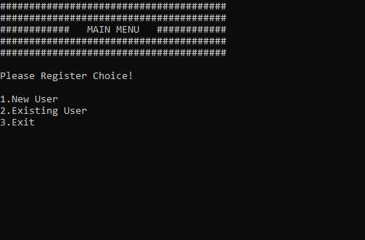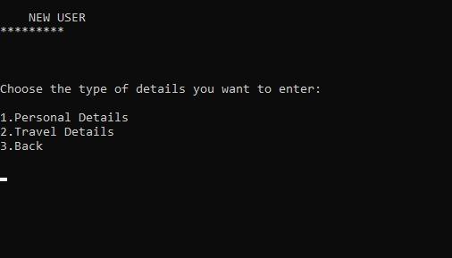

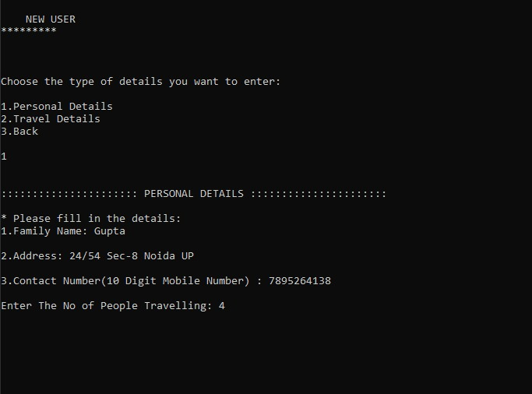

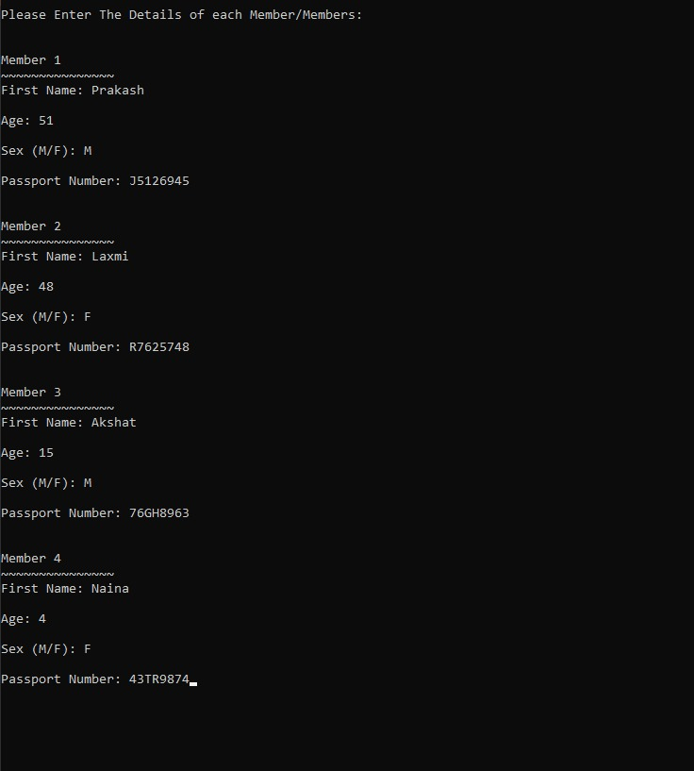

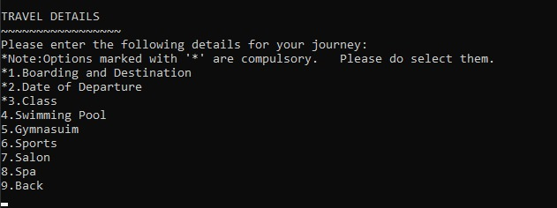

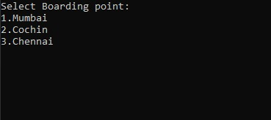

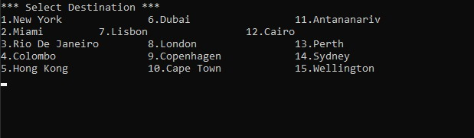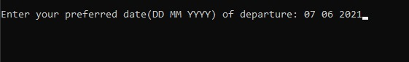

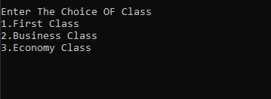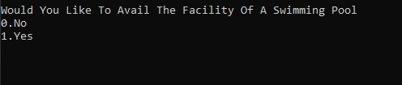

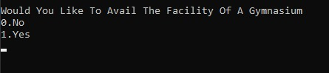

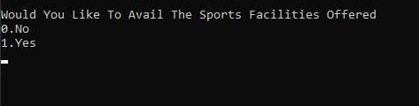

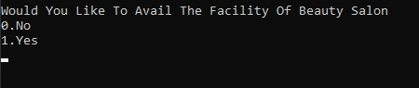

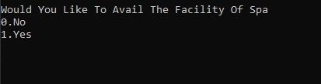

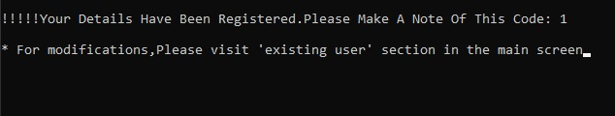

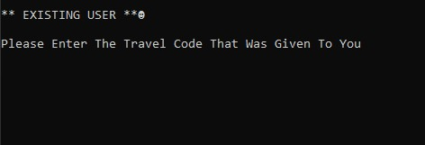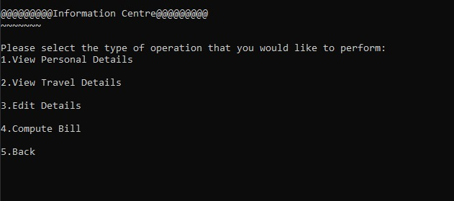

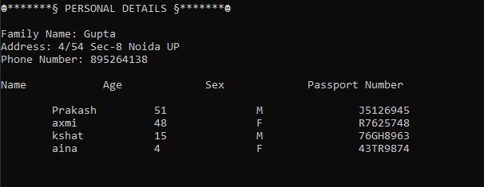

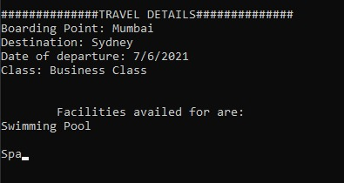

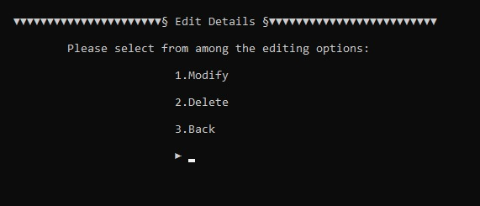

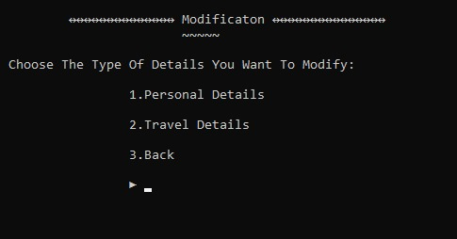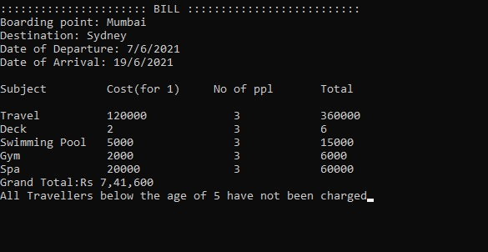

# CONCLUSION

This is a complete application that was designed for a Travel agency to manage their List Travel inventory and Proposed TRAVEL Management System: The proposed system provides lot of facility to the user to store information and displays the best results of the required location.

This Software is Efficient in maintaining customer's details and can easily Perform Operations on Customer’s record. This software also reduces the work load of the company. In Future, this system can launch website for ease reservations.

* Modify this system to perform additional operations such as modification the Registration date

of travels etc.

* This system will be extended in future to handle number of places and also provide facility of more vehicles.
* In future the system can be done online

# REFERENCES

* COLLEGE PPTs.
* W3schools
* Geekforgeeks
* Let Us C++

- Yashavant Kanetkar

* Object Oriented Programming with C++

- E Balagurusamy